# WALLMART DATABASE

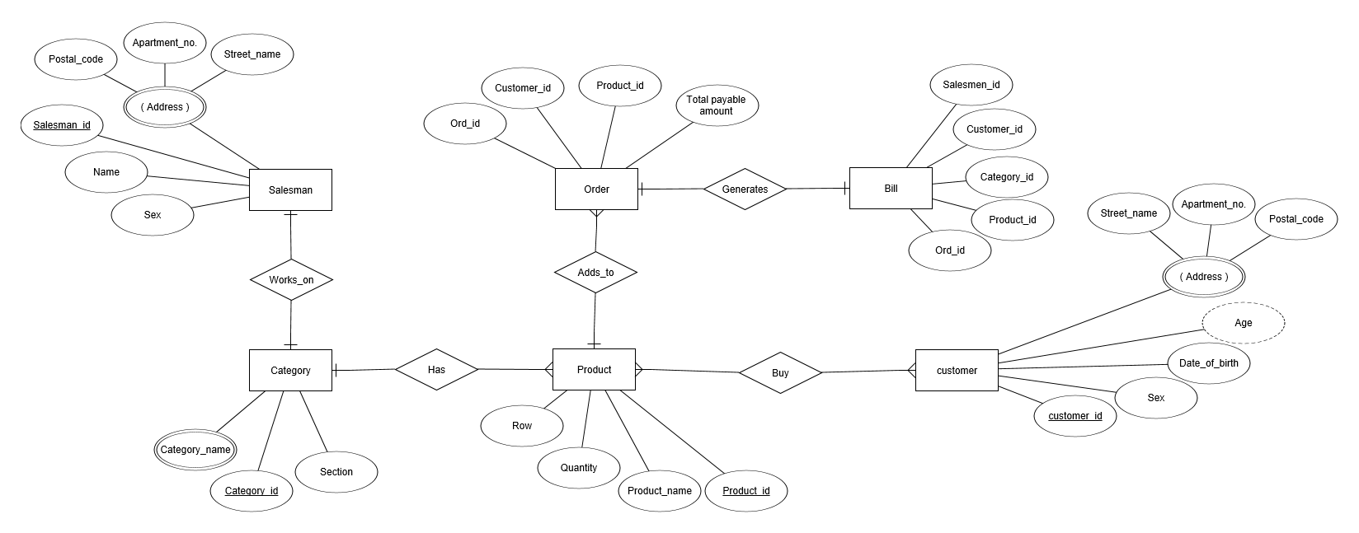

Entities:

* Salesman
* Customer
* Category
* Product
* Order
* Bill

Attributes:

SALESMAN:

1. Salesman id
2. Name
3. Sex
4. Address

* Postal code
* Apartment no
* Street name

CATEGORY:

1. Category name
2. Category id
3. Section

PRODUCT:

1. Product id
2. Product name
3. Quantity
4. Row

CUSTOMER:

1. Customer id
2. Date of birth
3. Sex
4. Age
5. Address

* Postal code
* Apartment no
* Street name

ORDER:

1. Order id
2. Customer id
3. Product id
4. Category id
5. Salesman id
6. Total payable amount

BILL:

1. Ord id
2. Customer id
3. Product id
4. Category id
5. Salesman id

Relationships:

1. Salesman works on category
2. Category has product
3. Customer buy product
4. Product adds to order
5. Order generates bill